**System of Equations**

* Two or more Linear equations together

***Solving System of equations:***

1. Graphing
2. Eliminations
3. Substitutions
4. **Solving by Graphing:** 
   1. One solution: Lines Intersect, different slopes
   2. No Solutions: Lines are parallel, same slope, and different y-intercepts
   3. Infinite solutions: Same slope, Same y-intercepts, Lines are the same.

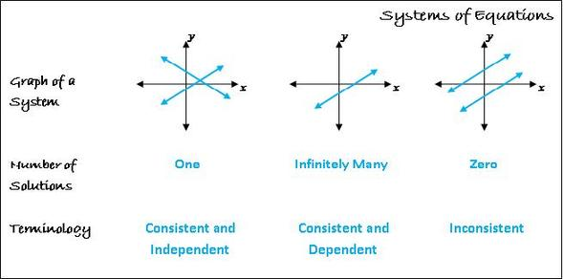

1. **Solving by Substitution: Replace!**
$$y=x-7$$

$$2x+y=8$$

2. **Replace x – 7 into y of 2nd equation**
$$2x+x-7=8$$

$$3x-7=8$$

$$3x=15$$

$$x=5$$

3. **Solve Y:**

$$y=5-7$$

$$y=-2$$



(5, -2)

**3. Solving by Elimination:**

**Add/subtract:** **Don’t forget to change all the signs throughout whole equation.**







**Multiplication: Make it Match!**





**Word Problems:**

**1. Define the variables that you want to find**

**2. Create equation that express the information given (you need 2 equations)**

**3. Solve your system of equation using algebraic methods**

**4. Is answer reasonable?**

**5. Label your solution appropriately**

**Example:**

**Jim had a summer lemonade stand where he sold small cups of lemonade for $1.25 and large cups for $2.50. If Jim sold a total 155 cups of lemonade and collected a total $265, how many cups of each type did he sell?**



**Graphing System of equation Inequalities:**

**< , > Dotted lines**

**≤ , ≥ Solid Lines**

**Shade Above if y > or y≥**

**Shade Below if y < or y ≤**

**Solutions are where the shades overlap each other.**

**Examples:**

